IAWA Gold Cup 2012

Venue: Castlemilk Community Centre, 121 Castlemilk Drive, Glasgow, G45 9UG
Date: 3rd November 2012
Entry Fee: £35.00
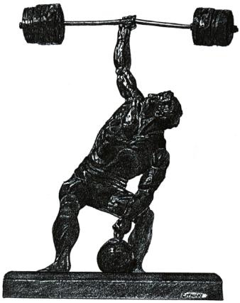
Weightlifting Timetable:

Weigh-In: 9am to 10am

Weightlifting Starts: 11am

Silver Cup entries (from those not holding a world title) will lift first followed by the Gold Cup

Required Information:

Name:………………………………………………………………………………………………………………………………………………………………………

Address:……………………………………………………………………………………………………………………………………………………………………

Date of Birth:……………………………………………………………………………………………………………………………………………………………

Age Group:……………………………………………………………………………………………………………………………………………………………….

Weight Category:……………………………………………………………………………………………………………………………………………………..

1st Choice Lift:…………………………………………………………………………………………………………………………………………………………..

2nd Choice Lift:………………………………………………………………………………………………………………………………………………………….

Home Phone Number:……………………………………………………………………………………………………………………………………………..

Mobile:……………………………………………………………………………………………………………………………………………….......................

E-mail:………………………………………………………………………………………………………………………………………………………………………

Signed:……………………………………………………………………………………………………………………………………………………………………..

Challenge Event:

Two Man One Hand Deadlift
Entries are sought for this challenge event; please enter Team Name and Entrants below.

Team Name:……………………………………………………………….

Entrants: 1……………………………………………………………. 2………………………………………………………………….

Banquet & Awards Ceremony

£15.00 per head
Ivory Hotel Address: 2 Camphill Avenue Glasgow, G41 3AY
Tel: 0141 636 0223, e-mail: enquiries@ivoryhotel.com , web site: http://www.ivoryhotel.com/

Day Trip to Dinnie Stones

4th October 2012
£15.00 per head

Leave – 9am – Castlemilk Community Centre

Arrive – 1pm – Potarch Hotel, Potarch, Banchory, Aberdeenshire AB31 4BD
Tel: 013398 84339. Email: info@potarchhotel.co.uk

Leave Potarch Hotel – 3pm

Arrive back in Castlemilk – 7pm

N.B. Trip will only take place if enough sign up to cover costs of travel. £15.00 given as indication only, price will be confirmed dependant on numbers.

Cost

Entry Fee: £35.00

Numbers for banquet:…………………………………………………… x £15.00 ………………………………Sub total £...............

Numbers for Trip to Dinnie Stones………………………………… x £15.00 ………………………………Sub Total £……………..

Grand Total £……………

If payment by cheque make cheques payable to Matthew J. Finkle

Deadline for entry form (and payment from UK) 20th October 2012. Overseas lifters can pay on day

Disclaimer & Declaration
DISCLAIMER
In consideration of IAWA (UK) accepting my application for membership; I hereby release all claims for damages, losses and injuries that I may hold against the IAWA (UK), their promoters, officials, coaches referees and assistants whilst participating in any IAWA events.
DECLARATION
I, the undersigned, understand the Rules and Regulations of the IAWA (UK), in particular to it's Drugs Policy; and I shall be circumspect in all matters relating to the drugs issue and fully understand that at any time I may be called upon to provide a sample for testing to Officials of the IAWA or Independent Sampling Officers which if found positive may render me with a LIFE BAN from the IAWA.

Signed:……………………………………………………………………………………………………………………………………………………………..

Hotels in the local area (Suggestions only)

Ivory Hotel,  Address: 2 Camphill Avenue Glasgow, G41 3AY, Tel: 0141 636 0223, e-mail: enquiries@ivoryhotel.com web site: http://www.ivoryhotel.com/ | Burnside Hotel  7 East Kilbride Road, Glasgow, G73 5EA  0141 634 1276 ‎ · theburnsidehotel.co.uk | Busby Hotel  1 Field Road, Clarkston, Glasgow, G76 8RX  0141 644 2661 ‎ · busbyhotel.co.uk | Carnbooth House Hotel  Carnbooth House, 80 Busby Road, Glasgow, G76 9EH  0141 644 3838 ‎ carnboothhouse.com

Promoters:
Andy Tomlin, 191 Ardencraig Road, Castlemilk, Glasgow, G45 0HG, Tel: 07814 323579,
e-mail: andytomlin91@yahoo.co.uk

Matthew J. Finkle, 7 Ardencraig Drive, Castlemilk, Glasgow, G45 0HD, Tel: 07736 808645,
e-mail: matthewfinkle@gmail.com

